LAB PROGRAMS
CSA1015-SOFTWARE ENGINEERING
Question 12
You are designing a Task Management System for a small team. The system should include the following features:
- User Login and Role Assignment
- Task Creation and Assignment
- Task Prioritization and Deadlines
- Progress Tracking and Reporting
Task: Prioritize these requirements using the MoSCoW and Kano models in Jira.
Step 1: Log in to jira account and create a new space from left side panel and select kanban template
Step 2: Give the name of project
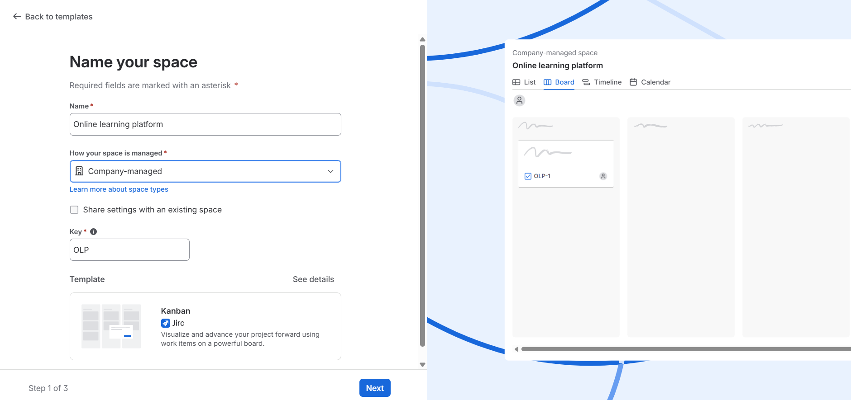
Step 3: Create the tasks in list and assign to team and date of task and priority level
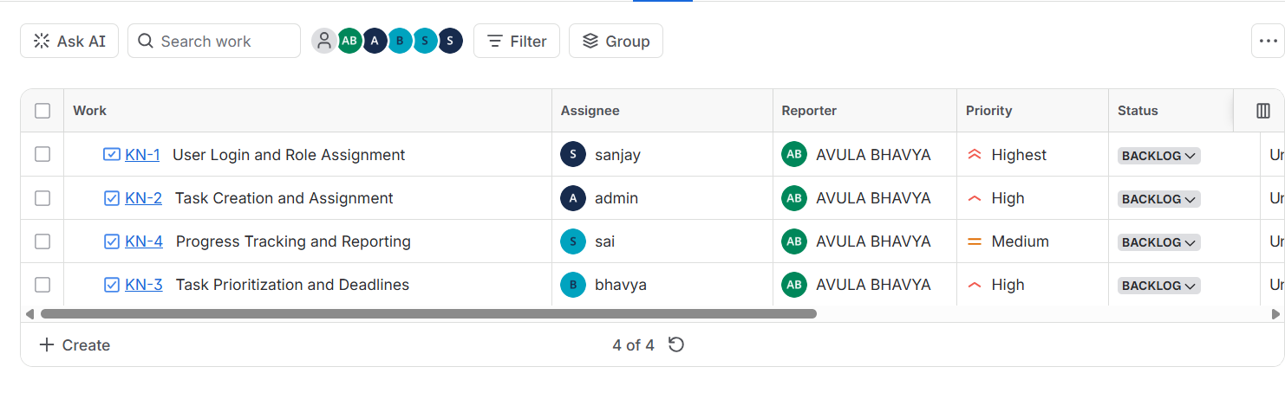
Step 4: Click on settings select work items in that select priority and edit to must, should, could, wont
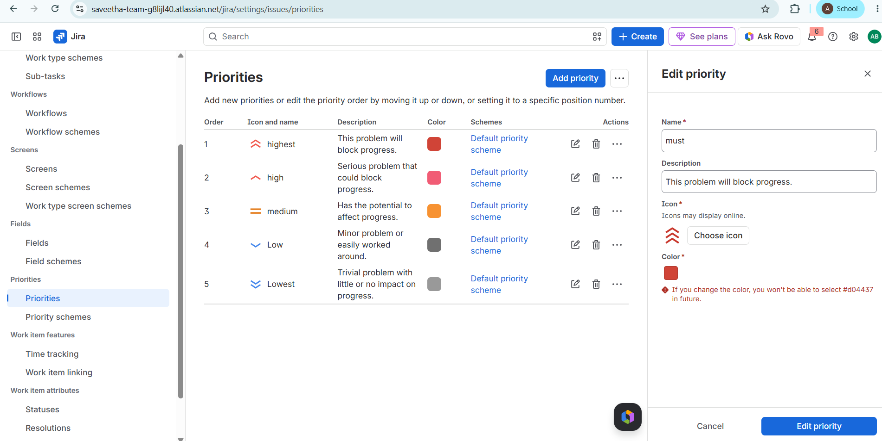
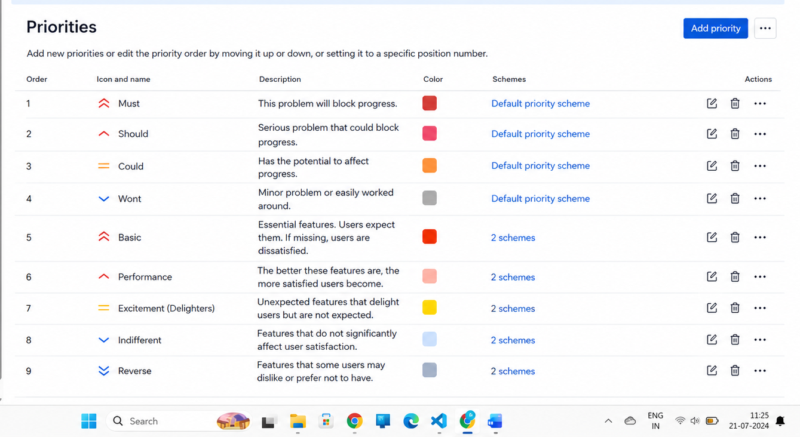

Step 4:Apply MoSCoW Prioritization
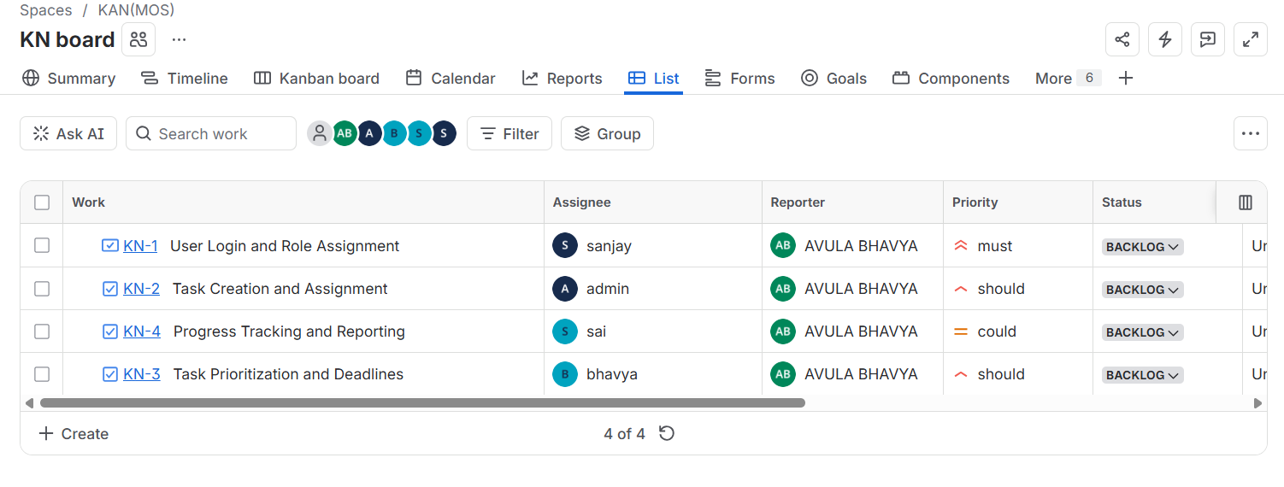

Step 5:Apply Kano Prioritization
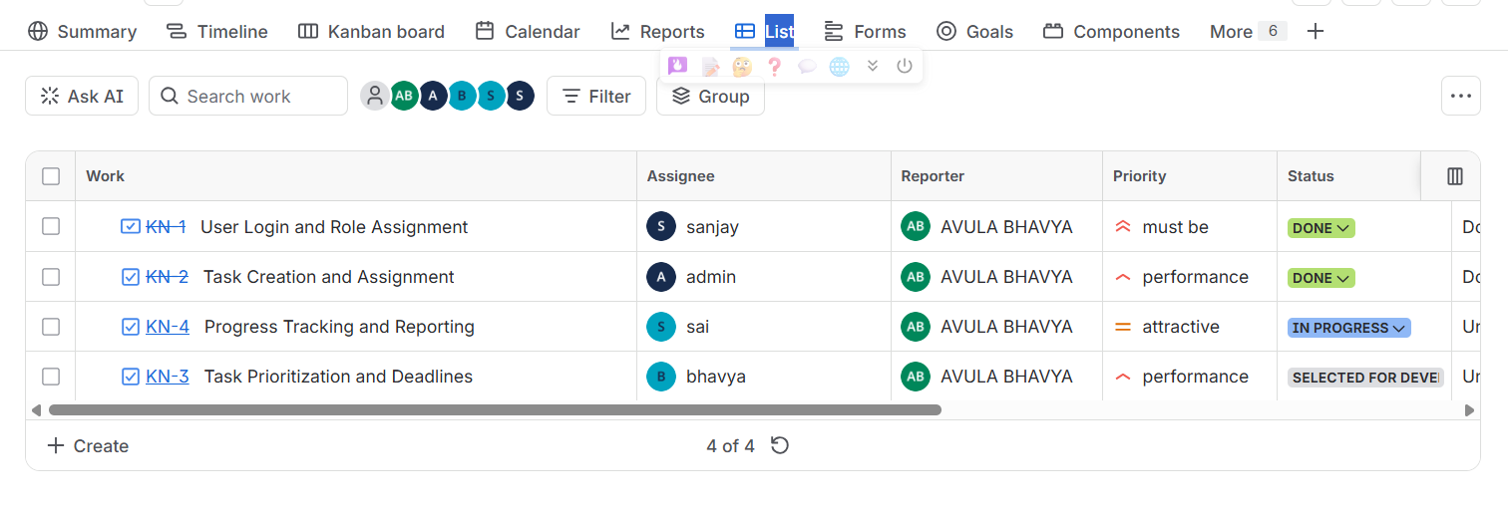
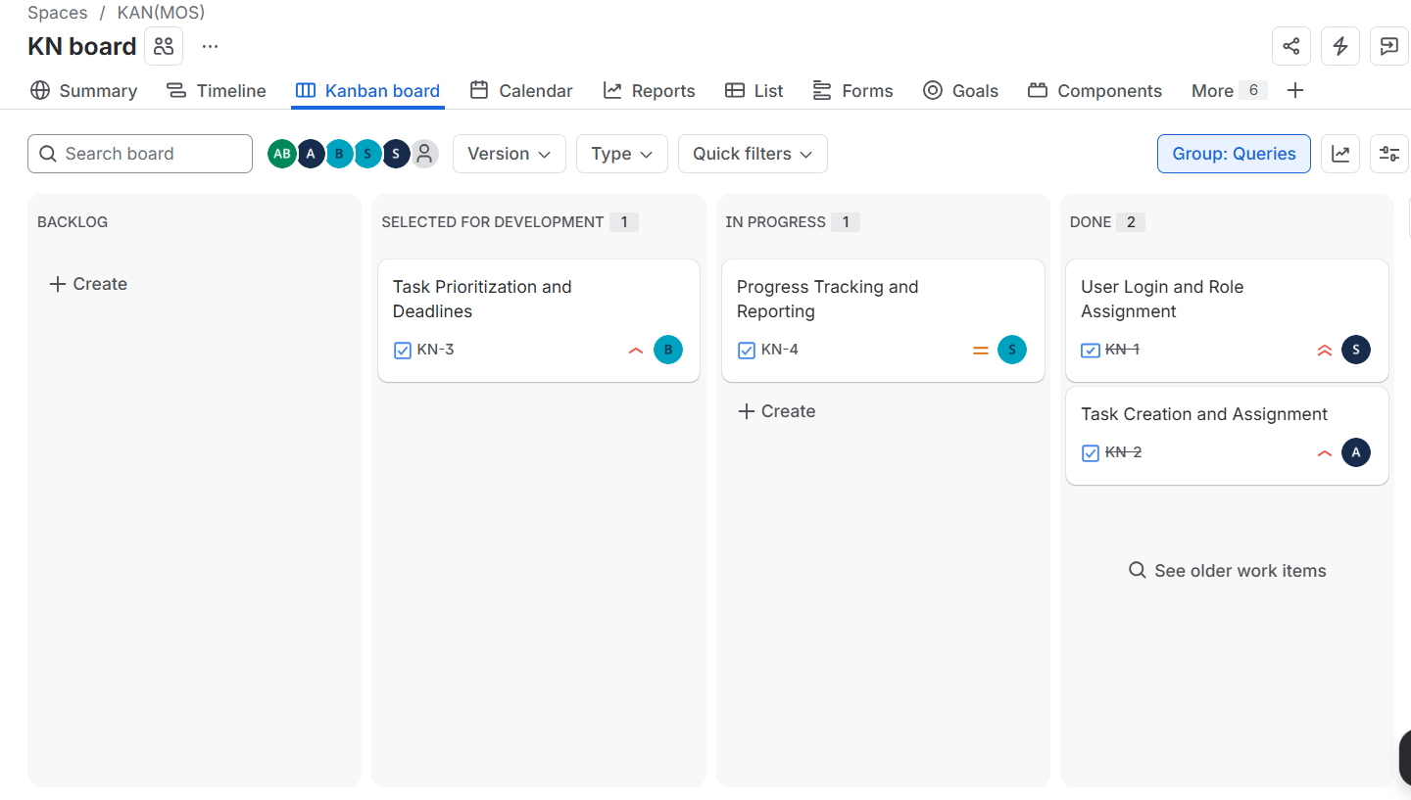
Step 6:We can verify all task in kanban board
Step 7: We can see the summary in summary option
